NOTES

Candlemas was originally an ancient festival marking the midpoint of winter, halfway between the shortest day and the spring equinox and was a Feast of Lights. It became a Christian festival commemorating the Purification of Mary and the Presentation of Jesus in the Temple forty days after his birth. It is also the last day of the Christmas season so it is appropriate to look back at Christmas as well as reflecting on a new year and turning our thoughts towards Lent and Easter.

Our first concert was five years ago and we sang a programme centred on Britten’s wonderful Ceremony of Carols. As it is such a seminal work for high voices we sang it again two years ago with harp accompaniment. The first half of tonight’s concert pays homage to Ceremony of Carols, using its structure and pieces similar in nature to those in the original work. We start and end with plainsong for the season of Candlemas.

The first group of carols consists of two from the 15th century and ends with a haunting setting of Yeats’ mysterious poem A Nativity by John Tavener (who died last year). The medieval There is no rose is the first of four settings of this text in this programme: you will hear Britten’s later in the first half.

Rocking is a traditional Czech carol and David Willcocks’ version captures the mood perfectly. Medieval texts have been a source of inspiration for many a composer of carols: I sing of a maiden has proved popular over the years and the 2 part setting by Patrick Hadley (1899-1973) has become a firm favourite. David put at the top of his score of This little babe the words ‘in tribute and in awe of Benjamin Britten’. He has taken the original as his inspiration and added rhythmic and harmonic twists of his own.

Our first concert also included Elgar’s The Snow, a chorus for women’s voices with two violins accompanying as well as the piano, and words written by Elgar’s wife Alice. It was written in 1894 and first performed by ‘Miss Hyde’s Society’ in March 1896.

The second half begins with a sequence of very well known carols but not in the versions we usually sing today. O come all ye faithful dates from c1740 and is in Latin and in triple time. John Foster (1752-1822) penned a very jolly Yorkshire carol While shepherds (words by Nahum Tate) which is well worth a revival. Charles Burney, the 18th music historian, wrote a charming 2 part setting of Charles Wesley’s Hark the Herald.

The next group consists of carols to medieval texts by local composers: there are two more very different versions of There is no rose, by Mark Browse and David Hansell, and another Out of your sleep, written when I was a student.

We have recently sung Michael Hurd’s Missa Brevis, both in concert and in services, and noted the influence of Britten in his writing. He too uses medieval texts for his carols in Canticles of the Virgin Mary. Two hymns describing the Virgin as the Queen of Heaven start and end the work. The middle piece in this group describes the crucifixion. The lively Adam lay ybounden is included in the first half.

The concert ends with a traditional 17th century carol for Candlemas, set to music by William Chappell in 1859. The text laments the end of the Christmas period, when there was little work to do in the fields and thus a time of enforced leisure, and the return of never-ending labour and Lent. Gooding carols were sung in exchange for money or food.
Carols for
Candlemas

Cantilena

Director: Jenny Hansell

Cantilena
Jo Browse, Kate Burnett, Elizabeth Burtenshaw, Sarah Cobby,
Harriet Hansell, Jenny Hansell, Rosemary Hensor, Louisa Jones,
Claire O’Brien, Sarah Russell, Harriet Sampson, Clare Thornton-Wood

Piano and Organ David Hansell
Violins Rachel Ellis, Katy Ellis
Reader David Hansell

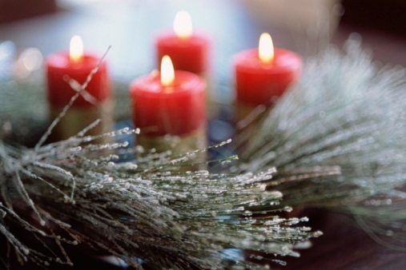

Saturday 31st January 2015
7.30 pm
St John’s, Broadbridge Heath
PROGRAMME

Letabundus Sarum chant
Nowell: Out of your sleep anon 15th c
There is no rose anon 15th c
A Nativity John Tavener
Ceremony upon Candlemas Eve Robert Herrick
At Candlemas Charles Causley

Rocking trad. arr. Willcocks
I sing of a maiden Richard Hadley
This little babe David Hansell
The Burning Babe Robert Southwell
The Snow Edward Elgar
There is no rose Benjamin Britten
Adam lay ybounden Michael Hurd
Canticles of the Virgin Mary no. 2

Letabundus

SHORT INTERVAL

Adeste fideles Douai MS c1740
While shepherds watched John Foster
Hark the herald angels sing Charles Burney
Ghost Story Dylan Thomas
There is no rose David Hansell
Out of your sleep Jenny Hansell
There is no rose Mark Browse
The Old Year John Clare
Canticles of the Virgin Mary Michael Hurd
Queen of heaven
Mary, mother, come and see
O Queen of Heaven

The Fight of the Year Roger McGough
Gooding Carol anon.

Refreshments will be served after the concert

www.cantilenachoir.jimdo.com

