Courtship and Love

The ups and downs of courtship
Away, thou shalt not love me John Wilbye (1598)
Gush forth, my tears William Holborne (1597)
De plus en plus Gilles Binchois (15th century)
Amours et ma dame aussi Adam de la Halle? (C13th)

Unrequited love
Fly not so fast John Ward (1613)
If it be love John Hilton (1627)
Plus dure Guillaume de Machaut (C14th)
A Robyn, gentil Robyn William Cornysh (c1515)

Contented love
It was a lover and his lass Thomas Morley (1600)
With owt dyscorde Henry VIII (c 1520)
E, dame jolie Anon. trouvère song (C12th)

Five Hebrew Love Songs Eric Whitacre (1996)
I Temuná (A picture)
II Kalá kallá (Light bride)
III Lárov (Mostly)
IV Éyze shéleg! (What snow!)
V Rakút (Tenderness)
Rachel Ellis (violin), Will Duerden (Tambourine), Jo Browse (mezzo soprano)

SHORT INTERVAL
Absence and loss
Chanterai por mon coraige Guiot de Dijon (late C12th)
Adieu m’amour Guillaume Dufay (c1460)
Those sweet delightful lilies Thomas Weelkes (1603)

Marriage
Arise, get up, my dear Thomas Morley (1593)
Whenever I marry William Lawes? (1652)
Hey ho, what shall I say? Thomas Ravenscroft (1609)
Il est bel et bon Pierre Passereau (1536)

Salut d’amour Edward Elgar (1888)

In Windsor Forest Ralph Vaughan Williams (1930)
A Cantata from Sir John in Love
I The Conspiracy (Sigh no more, ladies)
II Falstaff and the Fairies (Round about in a fair ring-a)
Sarah Russell (soprano)
III Wedding Chorus (See the chariot at hand)
IV Epilogue (Whether men do laugh or weep)

Medieval Ensemble
Harriet Hansell (voice, recorder, viola), Jenny Hansell (voice, recorder),
Rachel Ellis (violin), Harriet Sampson (voice)

String Ensemble
Rachel Ellis, Louisa Jones, Charlotte Bassett-Chan, Kimberley Knudsen (violins), Harriet Hansell (viola), Kate Burnett (cello), Will Duerden (double bass)

Refreshments will be served after the concert.

Grateful thanks as always to all the helpers behind the scenes and, in particular, to Chris Dubois for his invaluable help with publicity.
De plus en plus
More and more there is renewed, my sweet lady, noble and fair, my will to see you. Hence comes my very great desire to hear news of you.
Do not think that I hold back, since always you are the one whom I wish to obey.
Alas, if you are cruel to me I shall have such anguish in my heart that I shall want to die: but this would be without abandoning your service and still upholding your cause.

Amours et ma dame aussi
O love, and my lady too, on my knees I beg of you. My poor heart you have pierced through: O love, and my lady too, my condition you must rue; since your sweetness pierced me through.

Plus dure
Harder than a diamond or a lodestone is your harshness, lady, who feels no pity for your lover whom you kill as he desires your friendship.
Lady, your pure beauty which surpasses all – so I feel – and your appearance, simple and modest, bedecked with fine sweetness, smiling, and with an attractive welcome have wounded me so deeply in the heart as I looked at you that never shall I have joy until you shall have given me your grace.

E, dame jolie
Ah, pretty lady, my heart, my deceit, I put in your keeping, for I do not know your equal.
Often I go complaining and bemoaning in my heart over a discomfort which should rejoice the heart of every lover who is overcome by such an ill.
So greatly pleases me the sweet pain of love, that I must sing at its command.

Five Hebrew Love Songs
I A picture is engraved in my heart; Moving between light and darkness: A sort of silence envelopes your body, And your hair falls on your face just so.
II Light bride She is all mine, And lightly She will kiss me!
III ‘Mostly,’ said the roof to the sky, ‘the distance between you and I is endlessness; but a while ago two came up here, and only one centimetre was left between us’.
IV What snow! Like little dreams Falling from the sky.
V He was full of tenderness; She was very hard. And as much as she tried to stay thus, Simply, and with no good reason, He took her into himself, And set her down in the softest, softest place.

Chanterai por mon coriage
I would be singing for consolation, my heart is heavy with tribulation. Dark is my mind’s imagination, perish I must in desolation. From that far land gloomy and savage no man ever I see returning, to bring me tidings of my love’s safety. My grief never can cease from its burning. O God, aid those daring invaders: in heat of battle help the Crusaders. Look with compassion, pity our trembling! Now are the Saracen armies assembling!

Il est be lest bon
He is a good chap, my husband, I tell you, neighbour. There were two women from the same region asking each other ‘What’s your husband like?’ He’s a good chap….. He doesn’t annoy me or beat me, he does the housework and feeds the chickens while I enjoy myself. I tell you, neighbour, it’s a laugh when the chickens cluck: ‘Little coquette, cockle-doodle-do. What’s this?’ He’s a good chap……
Courtship and Love

Charlotte Bassett-Chan, Jo Browse, Kate Burnett, Elizabeth Burtenshaw,
Rachel Ellis, Cathy Garner, Harriet Hansell, Louisa Jones,
Kimberley Knudsen, Sarah Russell, Harriet Sampson, Laura Skuce,

Elizabeth Burtenshaw (Piano)

Conductor: Jenny Hansell

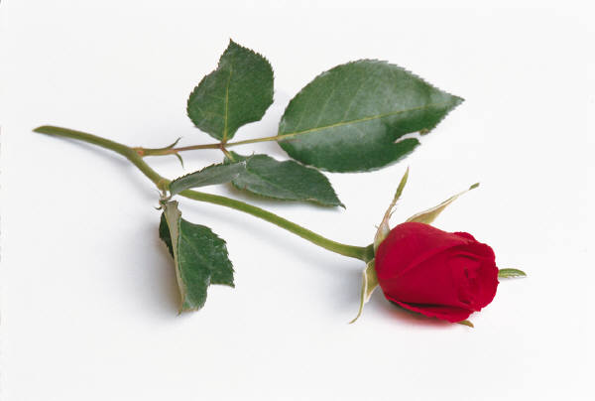
Saturday 25th May 2013

7.30 pm
Holy Trinity Church, Rudgwick
RH12 3EB

www.cantilenachoir.jimdo.com

