Carols at
Candlemas

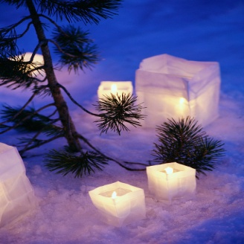

Cantilena

Conductor: Jenny Hansell
Organ: Philip Scriven

Saturday 4th February 2012
7.30 pm
Holy Trinity Church, Rudgwick

Cantilena
Kate Burnett, Elizabeth Burtenshaw, Laura Goldsmith, Rosemary Hensor, Judith Ironmonger, Katie Jackson, Kimberley Knudsen, Josie Pitchforth, Sarah Russell,
Laura Skuce, Clare Thornton-Wood, Megan Westcott

Cantilena is a small chamber choir for female voices based in the Horsham area. Many of the singers are music teachers and most play an instrument to a high standard: all have a love for singing and a desire to tackle a wide and challenging repertoire.
Previous concerts have included Britten’s A Ceremony of Carols, Chilcott’s A Little Jazz Mass, Byrd’s Mass for Three Voices, medieval carols, plainsong, themed madrigals and partsongs for a Flower Festival, barbershop arrangements and music by Brahms, Charpentier, Elgar, Mendelssohn, Mozart, Palestrina, Rutter, Stanford and John Tavener. Cantilena sings a cappella as well as accompanied by organ, piano and other instruments as necessary.

Cantilena is also available for weddings and functions. Forces can vary from a soloist, duet or small consort to the full ensemble including instruments.

For more details contact Cantilena:
Email: cantilena.info@gmail.com
Tel: 01483 275489

Next concert
Saturday 26th May 2012
7.30 pm
St John’s, Broadbridge Heath, RH12 3LD

Around the World in Eighty Minutes

19th and 20th century music including works by Elgar, Kodaly, Gershwin, the Beatles, and Ernst Toch’s Geographical Fugue
Tickets £10 are available tonight or from cantilena.info@gmail.com or 01483 275489

PROGRAMME

Mary, mother of Jesus

Ave maris stella – plainsong

Hail, Blessed Virgin Mary – trad. Italian

The Annunciation

Nova! nova! – anon. 15th century

Angelus ad virginem – anon. 14th century arr. David Willcocks

Magnificat sexti toni – Cipriano de Rore

The birth of Jesus

A virgin most pure – trad. English arr. John Rutter

Heute ist Christus – Heinrich Schütz

Sweet was the song – (i) anon. early 17th century
(ii) arr. John Rutter

Christe redemptor omnium – Claudio Monteverdi

SHORT INTERVAL

Luck visits

Sir Christëmas – William Mathias

Dieus soit en cheste maison – Adam de la Halle

Goday, my Lord – anon. 15th century

Old Year/New Year

In the bleak mid-winter – Harold Darke

The old yeare now – trad. English

A New Year Carol – Benjamin Britten

Deck the hall – trad. Welsh arr. John Rutter

Candlemas

Nunc Dimittis – plainsong

The mystery of Christmas

O magnum mysterium – Cristobal de Morales

