Carols for
Candlemas

Cantilena

Charlotte Bassett-Chan, Kate Burnett, Elizabeth Burtenshaw,
Rachel Ellis, Elisabeth Gardner, Laura Goldsmith, Harriet Hansell, Rosemary Hensor, Judith Ironmonger, Louisa Jones,
Kimberley Knudsen, Josie Pitchforth, Sarah Russell,
Harriet Sampson, Rachel Sherlock, Laura Skuce,
Clare Thornton-Wood

Heather Wrighton (Harp)

Conductor: Jenny Hansell

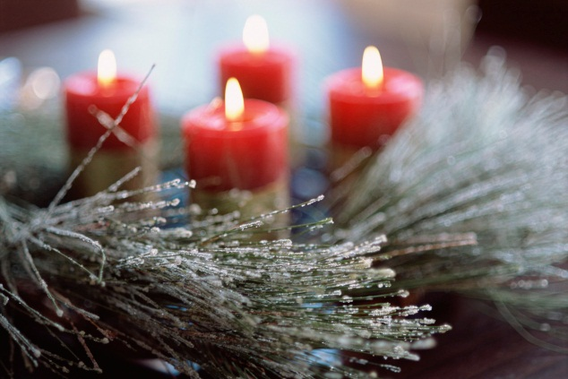

Saturday 9th February 2013
7.30 pm
Cranleigh Baptist Church
Programme

Letabundus (Hymn for Candlemas) Anonymous

Hodie Christus natus est Palestrina

Dancing Day John Rutter
Prelude
Angelus ad virginem
Of a rose, a lovely rose (piano: David Hansell)
Personent hodie
Interlude
There is no rose
Coventry Carol
Tomorrow shall be my dancing day

There is no rose (soloists: HH, LS, RE, RS) David Hansell

Rosa mystica Benjamin Britten

Interval of 10 minutes

A Ceremony of Carols Benjamin Britten
Procession (Hodie Christus natus est)
Wolcum Yole
There is no rose
That yongë child (soloist: Harriet Hansell)
Balulalow (soloist: Sarah Russell)
As dew in Aprille
This little babe
Interlude
In Freezing Winter Night (soloists: LS, RE)
Spring Carol
Deo Gracias
Recession (Hodie Christus natus est)

